**HUMAN EMOTION RECOGNITION**

**GROUP – 8**

**Literature**

5 Marks- comparison of more than 3 papers are presented (minimum 5).

1. Yoga Pose Detection
2. Improved Yoga Pose Detection Using MediaPipe and MoveNet in a Deep Learning Model
3. Yoga Pose Detection and Validation
4. Yoga Pose Detection and Correction using Posenet and KNN
5. Real-Time Yoga Pose Detection Using OpenCV and MediaPipe

**DATASET**

5/4 Marks – Dataset is identified, Analyzed the images in the dataset (or) acquired the images.

**IMPLEMENTATION –** 5 Marks -Implemented more than 5 methods

1. **EDGE DETECTION:**
   1. Sobel Edge Detection:

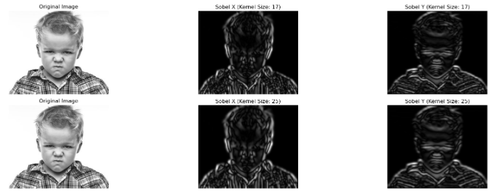

* 1. Laplacian of Gaussian (LoG):

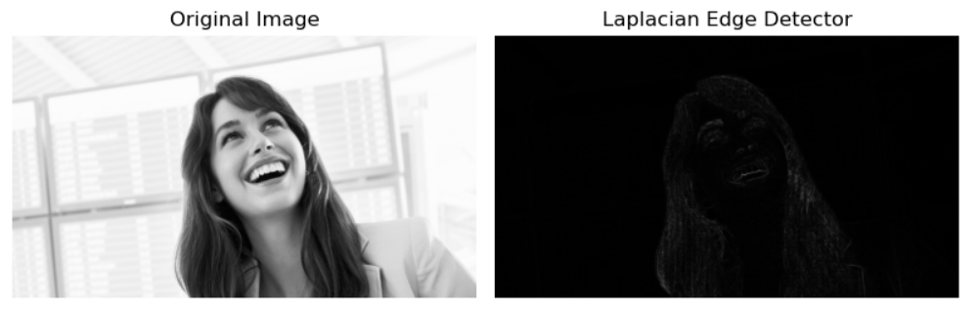

* 1. Canny edge:

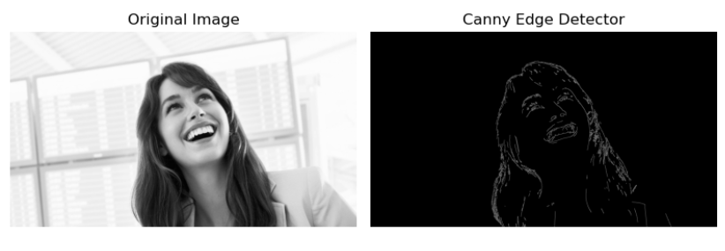

* 1. Robert’s Cross Operation:

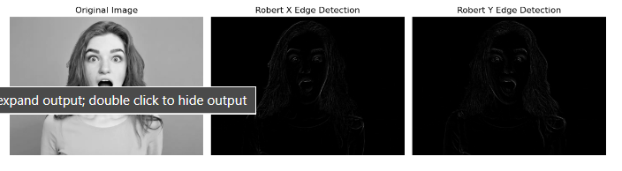

1. **FILTER:**
   1. Morphological Filters: - Erosion, Dialation

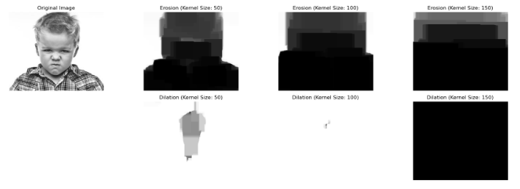

* 1. Mean Filter:

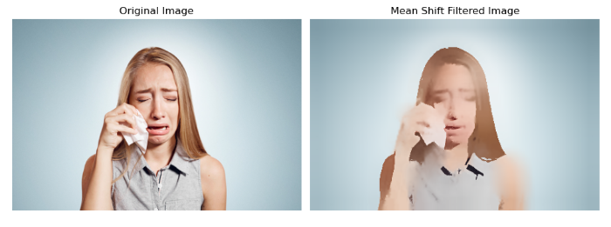

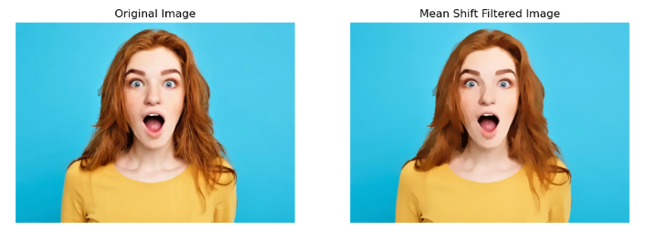

* 1. Non local Filter:

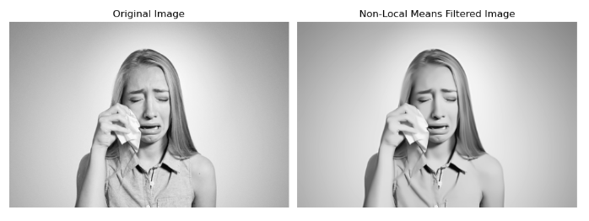

* 1. Bilateral and canny Filter:

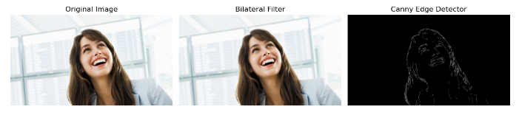

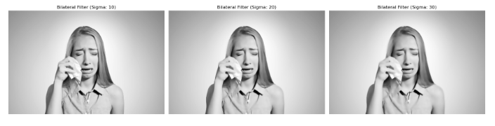

1. **HISTOGRAM EQUALIZATION:**
   1. Happy image:

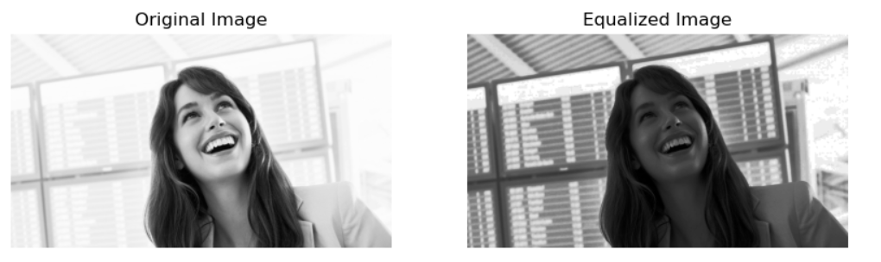

* 1. Angry image​:

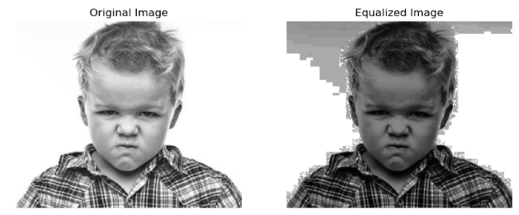

* 1. Sad image​:

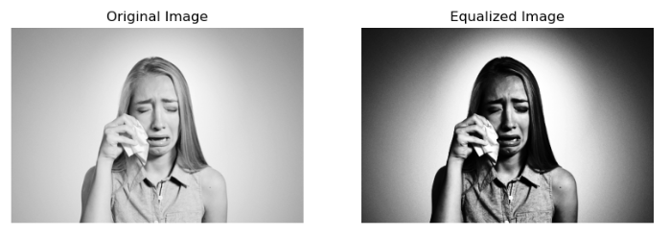

* 1. Suprise image:

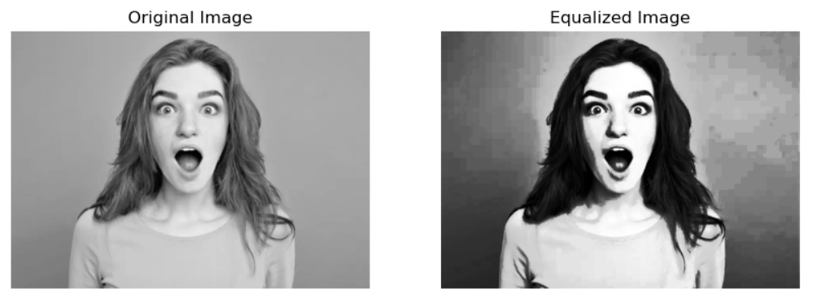

1. **FEATURE DETECTION:**
   1. SURF:

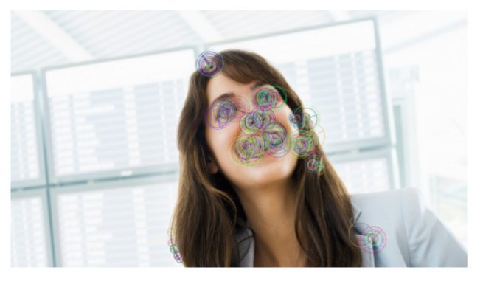

* 1. HARRIS CORNER:

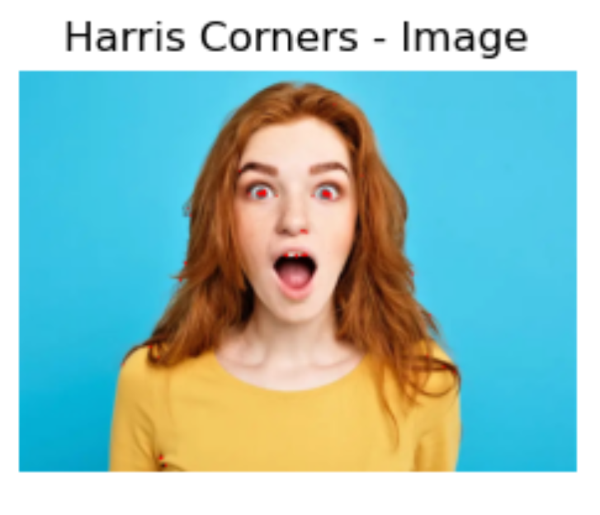

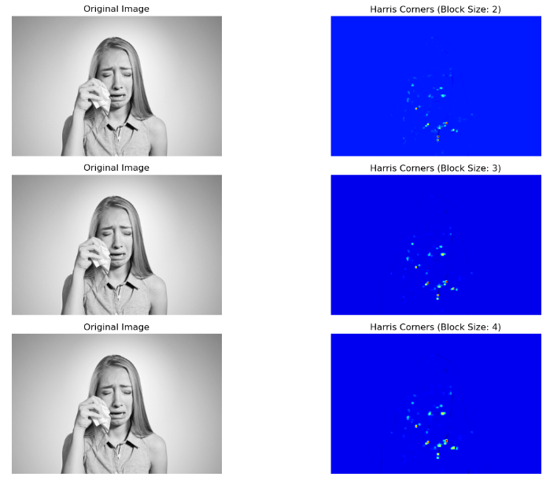

* 1. GLOH:

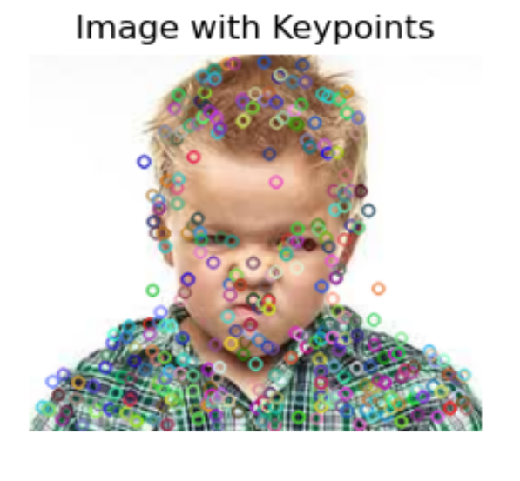

* 1. SIFT:

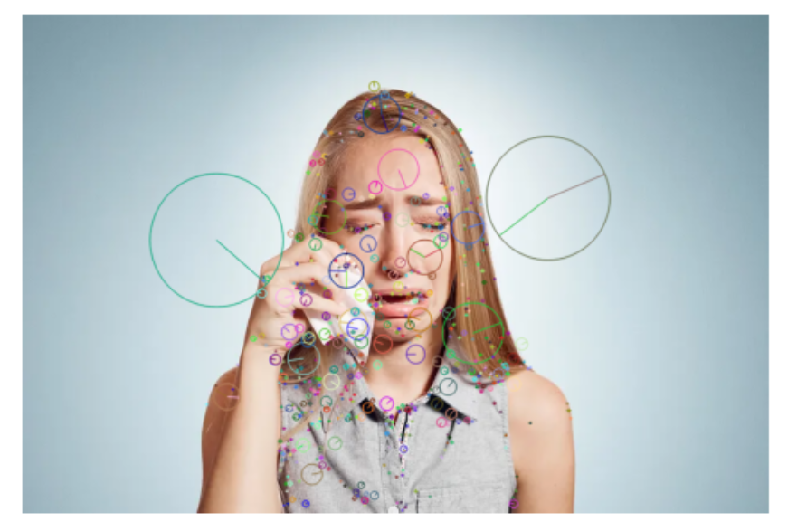

1. **PROJECTION MODELS:**
   1. Orthographic Projection:
   2. Pinhole Camera Model:
   3. Perspective Projection:
   4. Weak Perspective Projection​:
2. **COLOUR SPACES:**
   1. HSV​:

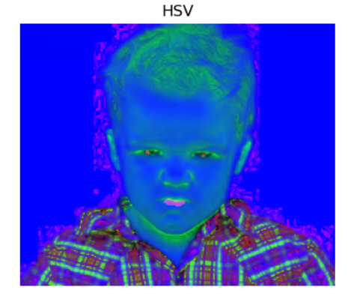

* 1. HSL:

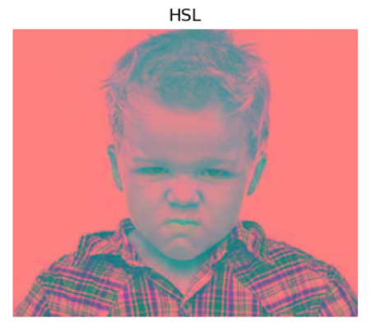

* 1. Grey Scale​:

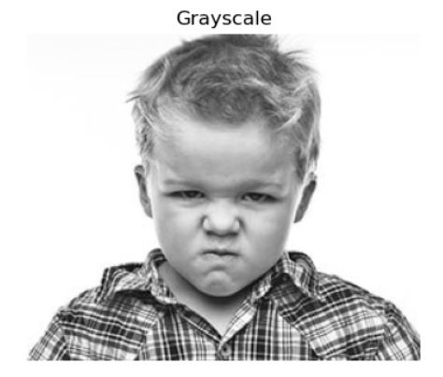

* 1. RGB​:

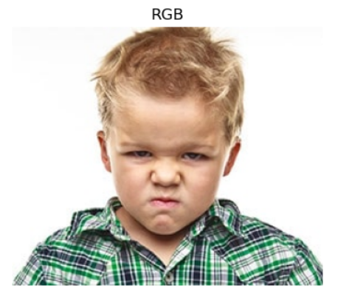

**Explanation on which of these methods are better in Recognition of Human Emotion:**